UML DIAGRAMS

**Use case diagram**

|  |
| --- |
|  |

**Activity Diagram**

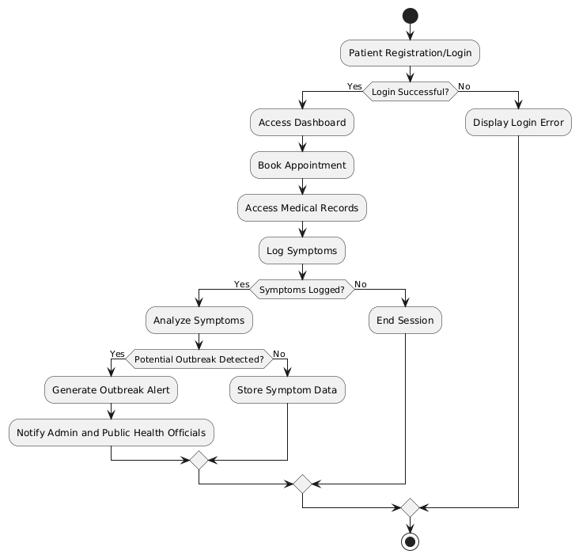

**Sequence Diagram**

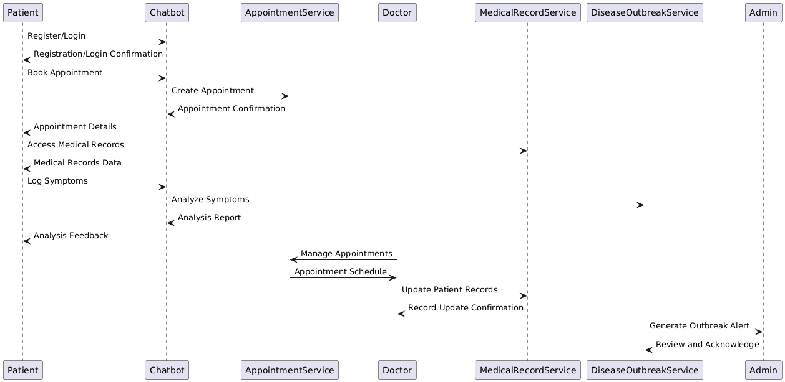

Class Diagram

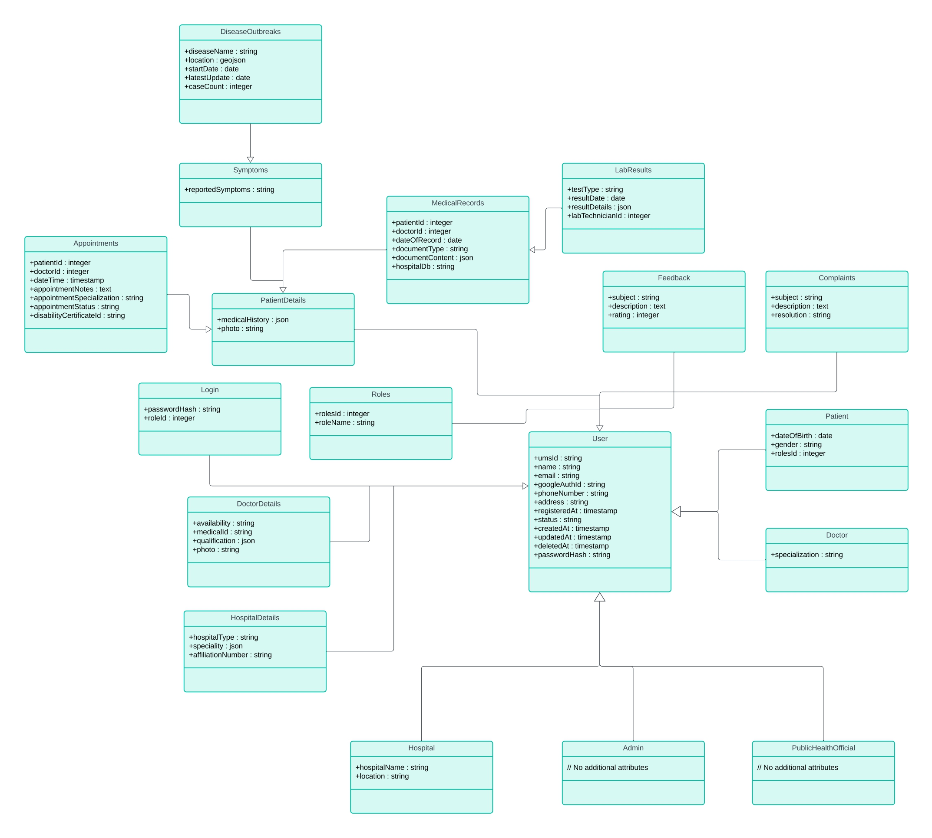

Object Diagram

